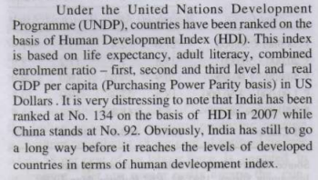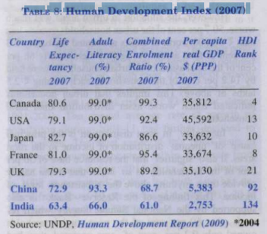

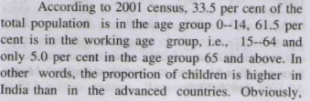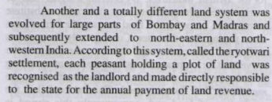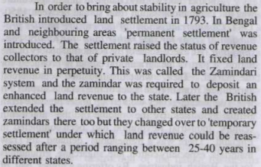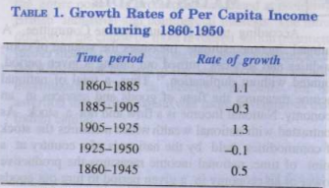

After postindependence the Government of India appointed the National Income Committee in August , 1949. o . The final report of the Na - tional Income Committee appeared in 1954.

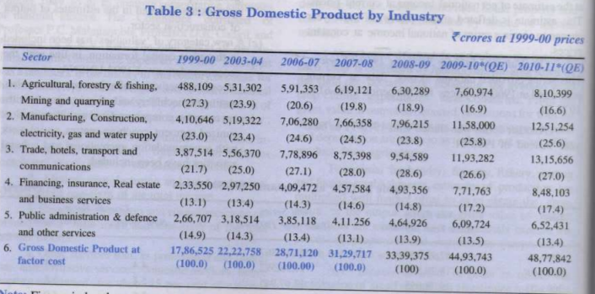

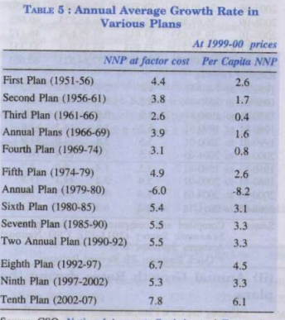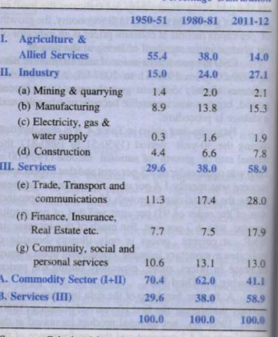

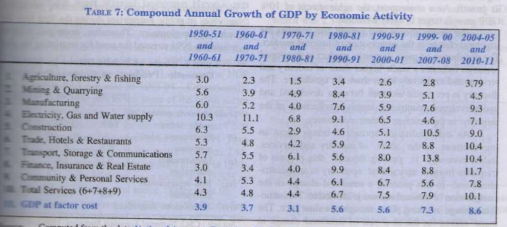

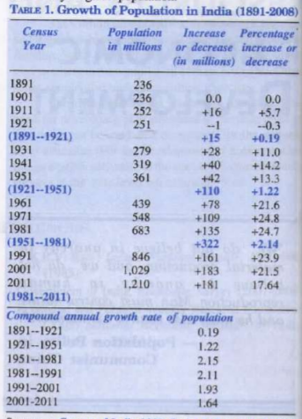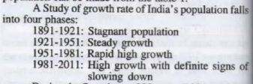

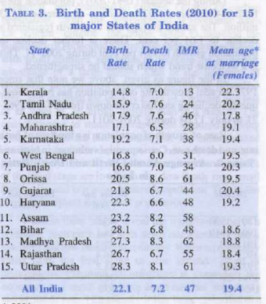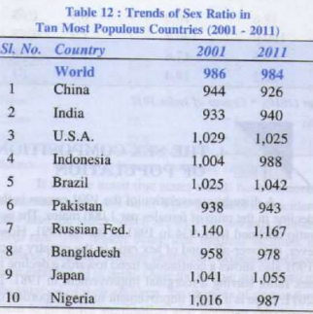

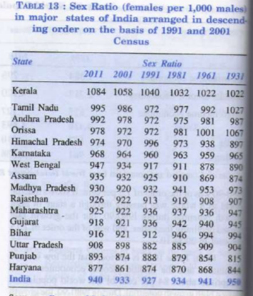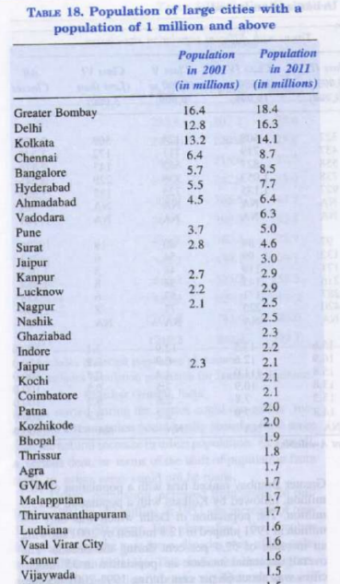

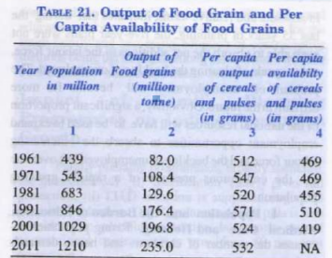

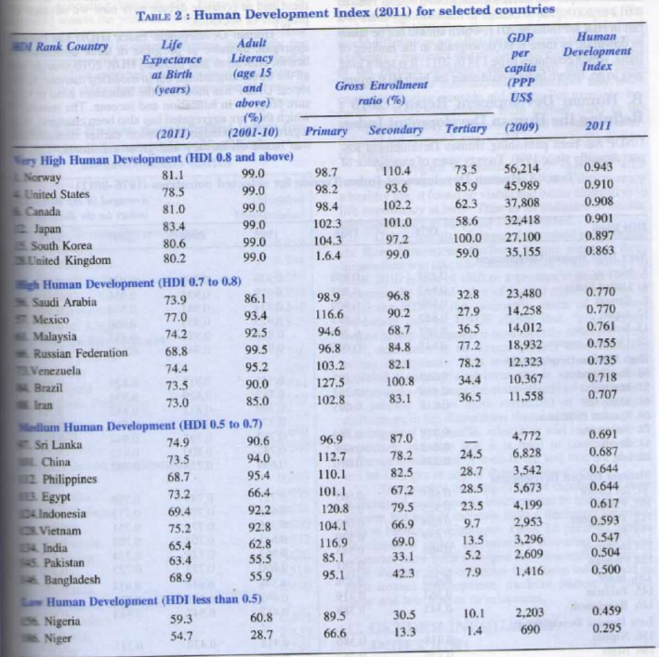

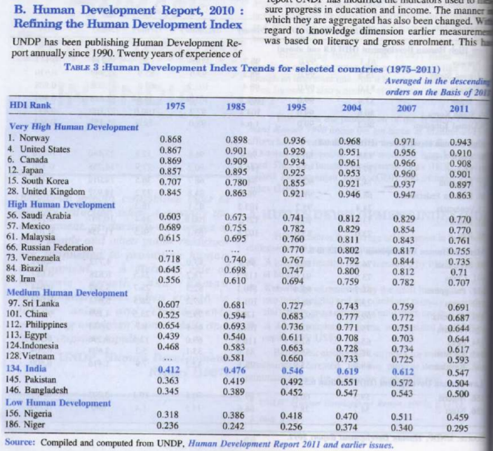

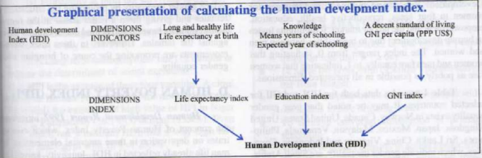

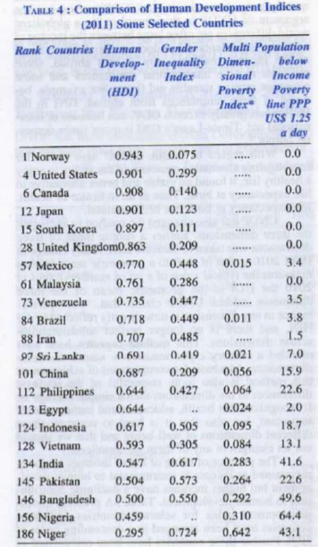

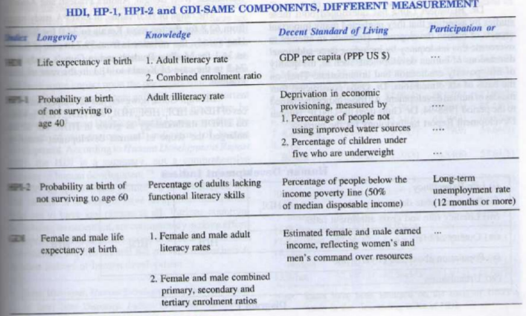

UNFPA published book " **India: Towards Population and Development Goal** " in 1997. And **Mahul-ul-haq** was main architechture of UNDPA book " Human Development in south asia "

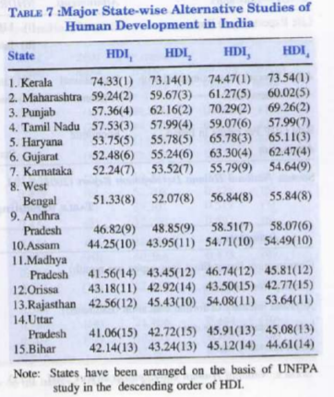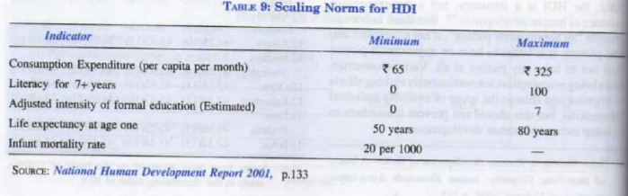

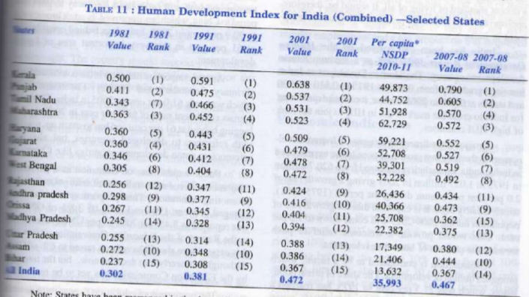

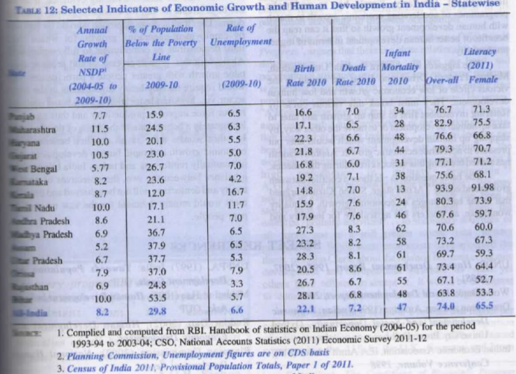

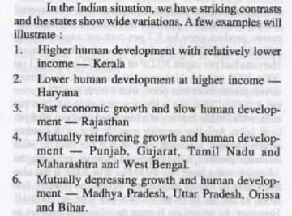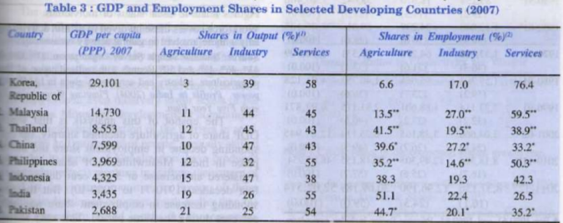

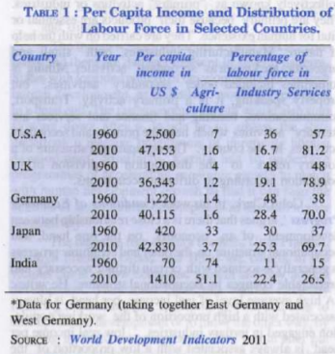 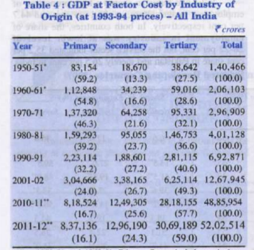

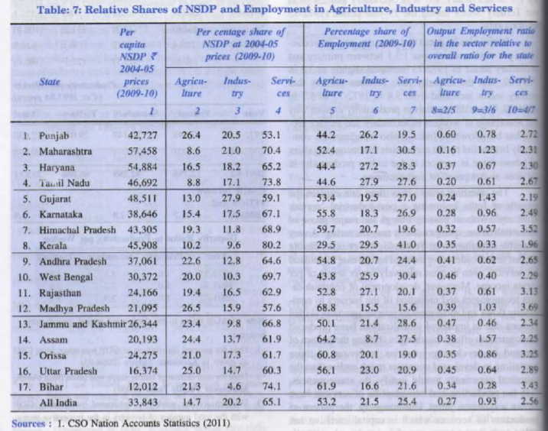

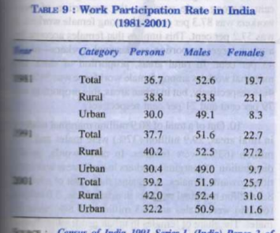

**Indian Agriculture : Green Revolution**

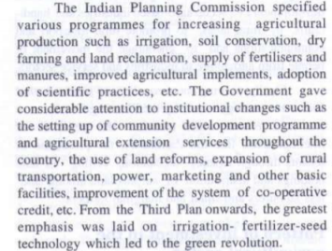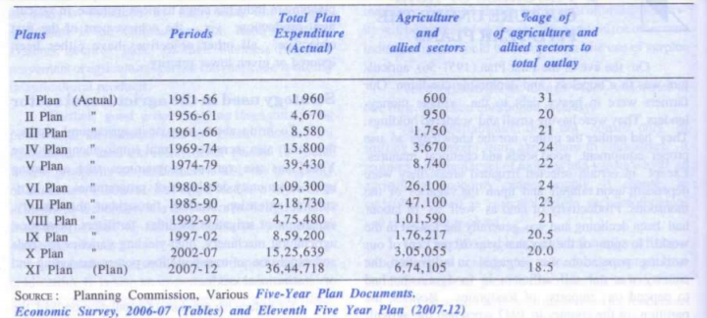

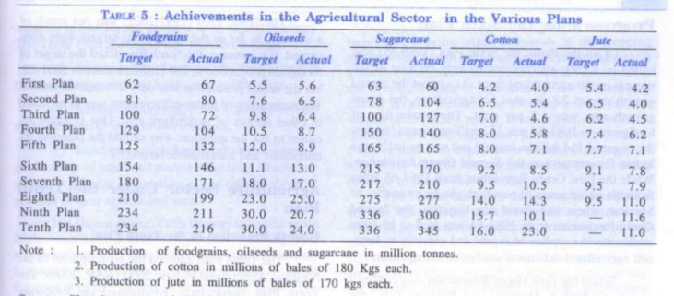

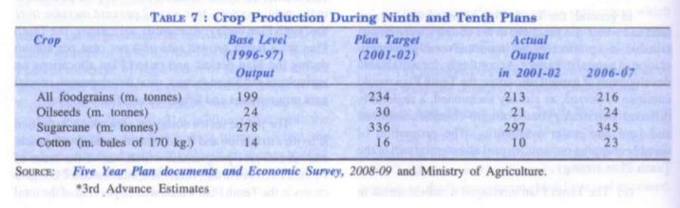

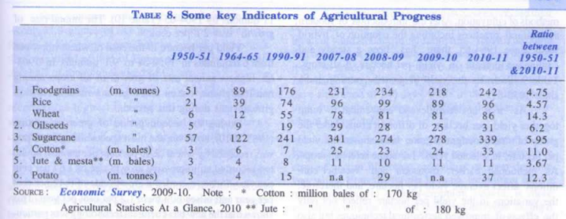

Then 11th planned was successfull as shown below 2010-11

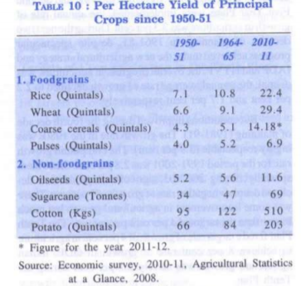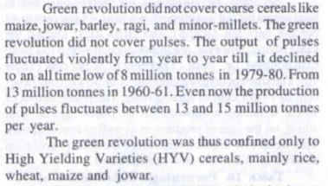

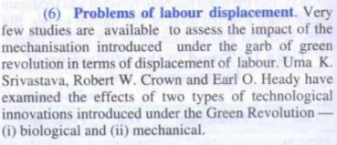

1st Green revolution - 1967-68 due to high yeilding variety of mexican wheat and dwarf rice variety

-- this revolution was confined mainly to punjab,haryana and westener UP

2nd Green revolution - 1983-84 due to supplies in inputs and services to farmer

-- this revolution spread to eastern and central state including w bengal,behar,orissa mp

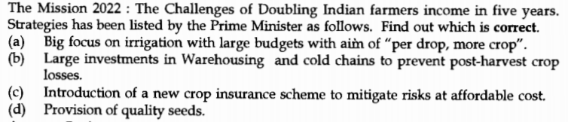

**Food Security.**

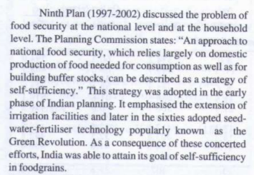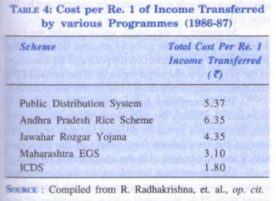

1. integrated child development scheme(ICDS) 2. Maharashtra EGS - Emplymnet Garantee scheme.

2001 antadoya anna yojna

M S Swaminathan - National commision on farmer

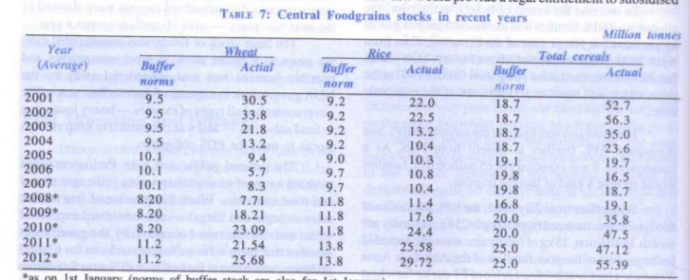

**Planning commision tendulkar commitee** found that all india population is poor on the basis of calories intake norm

**Rural defence ministry saxena commitee** found 50% population would be poor

And **national commision for enterprise and unorganises sector** **Arjun sengupta committee** found 77% population to be poor

US and european country are extracting ethonol from corn. and china are extracting ethonal from wheat corn as well.

**" Etiennie , G . (**1988) , Food and Poverty: India' s Half" Won Battle ."

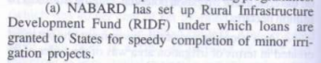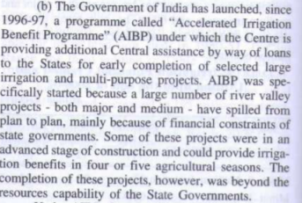

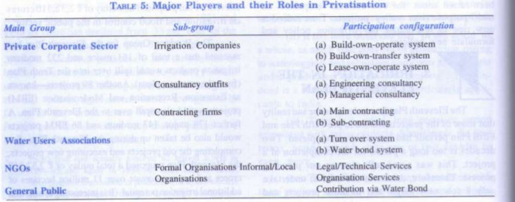

Anwar Alam , "Farm Mechanisation - Keeping Pace with Change"

since april 2003 GOI has adopted a new rational policy to benefit both producer.this new policy is meant to encourage private investment in urea plant and for the conversation of existing non-gas urea plant into NG(natural gas) or LNG(liquefied natural gas) urea plants which are clean,efficient and cost effective.

**SEED**

**National SEED corporation(NSC)** in 1963 and **state farm corporation in india**(SFCI) 1969 to produce and supply quality seeds

**Breeder seed organise** by Indian Council of agriculture Research(ICAR).

**Foundation seed** resposbility of production by NSE and SFCI

Finally , certified / **quality seeds** are produced and distributed for all farmer

**SEED bank** setup in **1999-2000** . Seed bank is implemented through **NSC, SFCI**

**Zamindari system** intoduced by --**lord cornwallis** in 1793 in bengal

**Mahalwari tenure** -- introduce in agara

-- Under Mahalwari tenure village land were held jointly by the village communities, the memebr of which were held jointly and severally responsible for the payment of land revenue.

it was **product of muslim**

**Ryotwari Tenure** **-- sir thomas** in madras in 1972

it was product of **hindu tradition**

land may be held in single independent holding.indiviual holder were directly responsible to the state for payment of land revenue

Ceiling on land holding ---- D R Gadgil

Mr. P.S . Appu --' Barga operation ' type land reform

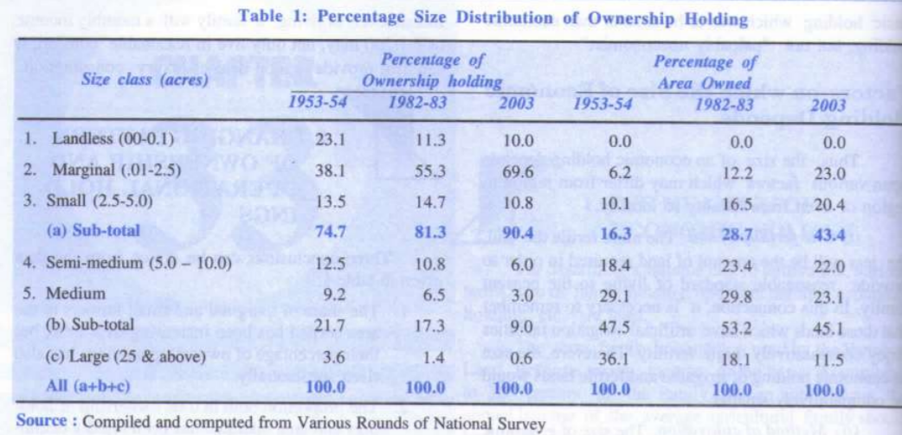

**Credit Farming**

Types of Co-operative farming

1. Co-operative tenant farming 2. Co-operative collective farming

3. Co-operative better farming 4. Co-operative joint farming

Adat Farmers Co-operative bank(AFCB) in kerala district is success story for all

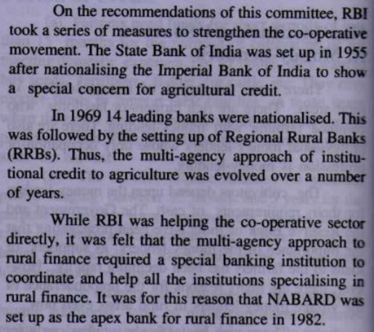

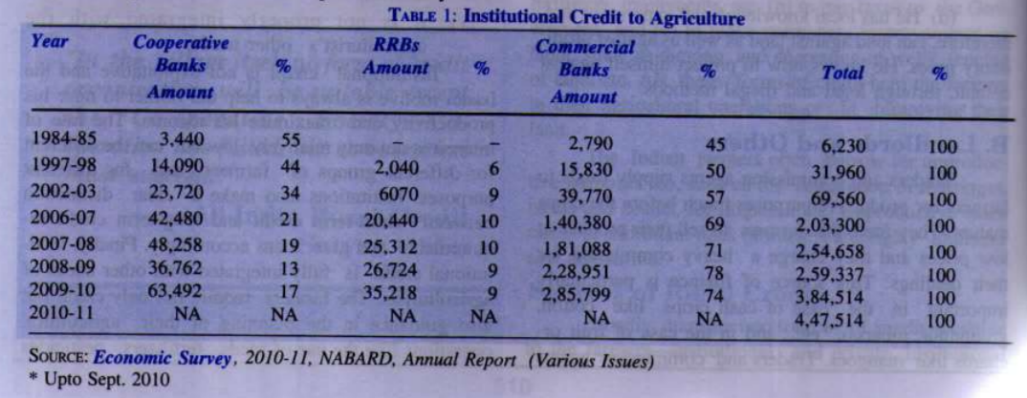

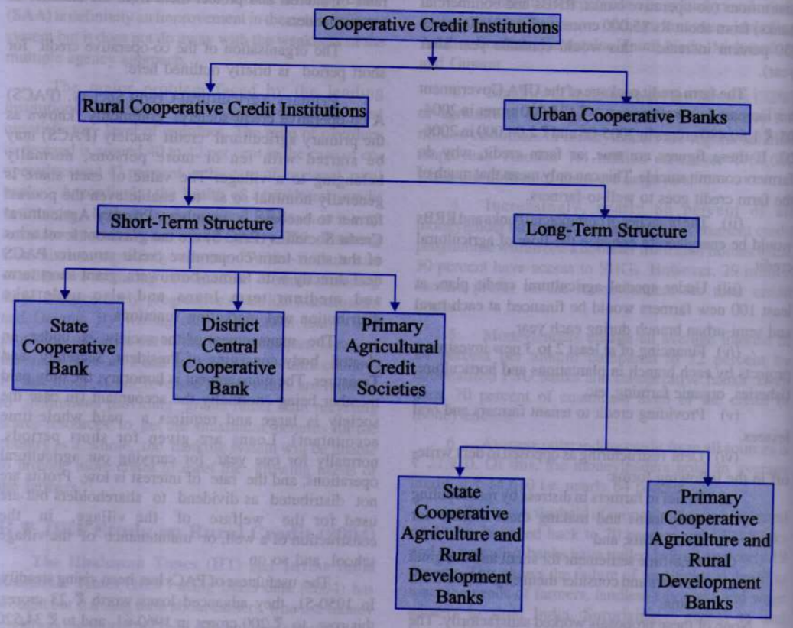

PRimary Agriculture Credit Society(PACS) -- this is grassroot level finance provider. directly deal with farmer borrower.

enable poores farmer to become member.

and profit will be used for village welfare. this target particularly weaker section the small and marginal farmer

PAC are dependent on the finance provided by cooperative bank

From 1970 - commercial bank fund made available to PAC

Land development bank was made by madras in 1929

from Oct 1980 - Goverment has extended **integral rural development program(IRDP**) to all development blocks in country and ask commercial bank to fianace

**GUPTA committee** set up by RBI for **agriculture credit** in 1997 and implement in 1998 and recommend following point:

1. Free intrest rates on farm loans

2. scrap 18% target for agriculture lending

3. offer farmers a composite credit package

**Gadgil comittee(Nariman committee)** recommend " **Area approach**" to national bank accepted by **RBI** in 1969

**finalize LEAD BANK Schecme (LBS)** for 380 distict

Aim of LBS -- one of commercial bank perform as lead bank in disctict for **coordition credit deployment in a district**.

Under the scheme , the lead bank act as leaders **to bring about co-ordination of co-operative bank,commercial and other financial institution to bring about rapid economic development.**

Following important benefits are expected to flow from the scheme.

1. the whole country is serve by well knit system of commercial and cooperative banking

2. branch expansion, supervision and guidance have become effective

3. dynamic relation between commercial bank , cooreative credit intitute and goverment authority at district level

4. close integration of credit and banking bussiness with other activity

4. major bottelneck in developemnt of the district are identified and lead bank bring pressure on the appropriate agencies to take remedial action.

**RBI** **setup High Power Commitee(HPC)** in march 1976 to monitor the overall progress of LBS and to issue guidlines for effective functioning of scheme

1978-79--gov **introduce integrated rural development programm(IRDP)**

Public sector bank were advised to formulate **special agriculture credit plan(SACP)**

public sector adopted new strategy for rural lending " **Service Area Approch** " in **feb 1988**

under which each semi urban and rural branch of commercial bank was assigned a specific area

**fianance minister tiwari scheme** launch all over india in **April 1989**

slogan for this was " **Bank for every village**"

On RRB - **Narsimham Commitee on financial system(1991**) evaluate working of **RRB**

Following recommendation **of narasimham commitee**--:

1 commercial bank should segregate the operation of thier rural branches through formation of one or more subsidiaries

2. bank should have freedom to swap rural branches --banks with fewer rural branches in certain areas

**NABARD should help RRB** to earn higher level of intrest income for thier surplus cash balances

**Khusro Committee on RRBs:**

-- under chairman of Khusro observed that the weekness of RRBs .RRBs had accumulated huge losses

--on recommendation od narsimha and khusro committee In 2004 ,finance minister anounsce improve strentgh and function of RRB's

**Restructuring of RRBs**

RBI appointed **bhandari commitee to suggest for restructuring RRBs**.Most of recommendation of bhandari commitee are being **implemented**

**NABARD monitor working of RRBs** regarding productivity,cash managmentadvance portfolio and recovery performance

**NABARD and its Role in rural bank**

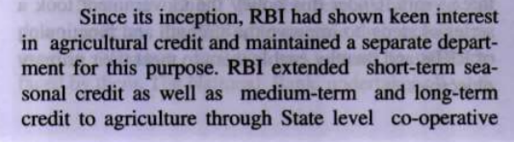

**RBI** setup **Agriculture Refinance development corporation(ARDC)** to provide refinace support to the banks to promote programmes of agriculture development

Also setup **NABARD** in **jully 1982** by an act to take over the functions of **ARDC** and refinancing function of **RBI** in relation to co-opreative banks and RRBs.

**Director board of NABARD** is **deputy governor of RBI** bieng appointed as **chairman** of **NABARD**

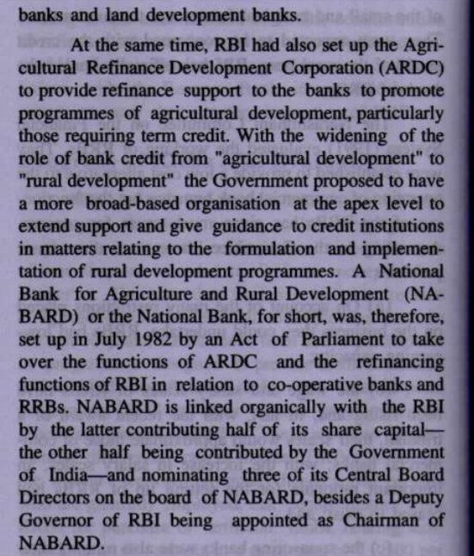

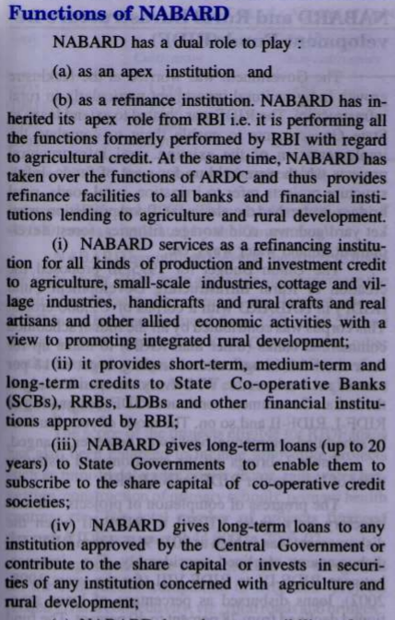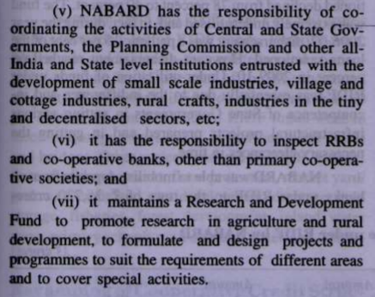

**Rashtriya krishi bima yojna** - **1999-2000**

**Farm income insurance scheme(FIIS)**--2003-2004

**Weather based crop insurance(WBCIS**) --2007-08

**SHG**(**Microfinance** or **microcredit**) program introduce by **NABARD** and implemented by **RRBs**, cooprative bank etc.

Microcredit -" Banking with the poor "

**Kisan credit card (KCC)-** introduce in 1998-99. **KCC holder also provide personal accident insurance cover**

- **NAFED** promotes interstate and export trade of farm produce. it export commodities like onions, pulses, chillies,garlics.

- **NAFED** is central nodal agency for undertaking price support operation for pulses

- **NAtional Co-oprative development corporation (NCDC)** was setup in **1963** -planning,promotingprogram for production,processing storage and marketing of agriculture produce

**Capacity storage** - FCI > NCDC > various agencies through NABARD > SWC > CWC

- **Employment Guarantee Scheme (EGS)** introduce by **maharashtra in 1977**

- **20-point programme** in **1975** for landless labour and other weaker section

**procurment price**>=MSP

**Economic cost** == Procurment price + transport price+storage price

**Fair and Remunerative price(FRP)** - sugar mills have to pay to sugercane farmer

**MSP** is announce for limited number of crop --not all

Mere announcment of MSP does not mean assured procurement

Higher MSP can also lead to inflationary pressure

**MSP** regime is also blamed for the skewed croping pattern of the nation

**MSP** is announced for cereals, pulses as well as commercial crops like jute sugarcane etc but MSP not announced for any fruit

**CRR** -- Bank keep money with RBI without intrest

**SLR**-- Bank will keep money with them not with RBI